
User Manual

Multifunctional detector
WE-T800 User Manual

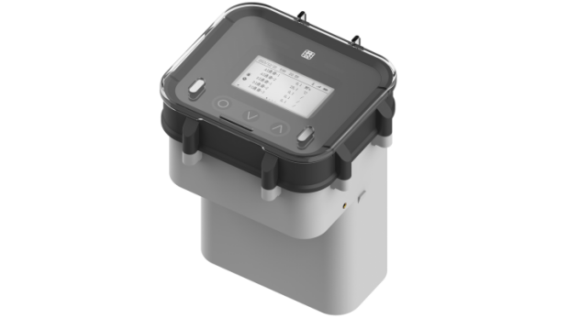

Hainan Shidian Technology Co., Ltd. U-WES-T800-CN1 Hainan Shidian Technology Co., Ltd. U-WES-T800-CN1

preface
- This manual serves as an instruction manual covering various product functions, wiring methods, operational procedures, and related usage details.
- Before operating, please read this manual carefully and use the product correctly to avoid unnecessary losses caused by incorrect operation.
- After reading, please keep it in a place where you can easily access it for reference during operations.

pay attention to
- If this manual is modified due to feature upgrades or other changes, please refer to the newly released document.
- We strive to ensure the accuracy of this manual. If you find any errors, please contact us.
- Please use this product in accordance with its characteristics and comply with national and regional laws and regulations.
- Reproduction and duplication of the contents of this manual are strictly prohibited.
- The final interpretation rights of this manual shall be reserved by the Company.

edition
U-WES-T800-CN1 First Edition February 2026

Confirm packaging content
After opening the packaging box, please check the contents before starting the operation. If you find any errors in model or quantity, or physical damage to the appearance, please contact our company.
The product packaging content is specified in the standard configuration list.
Product Standard Configuration List
order number | name | quantity | remarks
1 | Multifunctional detector | 1
2 | instructions | 1
3 | antenna | 1
4 | certificate | 1
Note: Customized products may differ slightly from standard products. Please refer to your order for details.

Multifunctional Detector 1 1

preface II preface II
pay attention to II pay attention to II
edition II edition II
Confirm packaging content III Confirm packaging content III

1. Product Overview 1 1
- 1.1. Product Introduction 1 1
- 1.2. Product Features 1 1
- 2. Technical Parameters 3 3
- 3. Product Structure and Dimensions 5 5
- 3.1. External dimensions 5 5
- 3.2. Materials 5 5
- 4. Installation and Use 6 6
- 4.1. Delivery Inspection 6 6
- 4.2. Installation and Usage Notes 6 6
4.3. Interface Wiring Schematic 7 7
4.4. Installation Schematic 8 8
5. Operation 11 11
5.1. Display and Operation Unit 11 11

5.2. On-site Operations 14 14
- technical parameter
import
interface type | 1 RS485 channel, 2 AI channels, 2 DI channels
RS485  Communication rate | 4800-115200bps
RS485  protocol | MODBUS-RTU
AI signal type | 4~20mA
DI signal type | Switching quantity, pulse counting
output
Output power supply | DC3.6V/5V/12V, adjustable
signal transmission
4G | Three-year data plan (100MB/month)  Supports MQTT, HTTP, and WES cloud service protocols  LTE FDD B1/3/5/8  LTE TDD B34/38/39/40/41 (full frequency band)  Speed (Mbps) LTE FDD: 10.3 (DL) / 5.1 (UL)  LTE TDD：9.1(DL)/3.1(UL)  Antenna interface type: SMA female connector
sampling period | Settable from 10s to 18h
Reporting cycle | Settable from 10s to 18h
Electrical specifications
Power Supply Voltage | Lithium battery with 114000mAh or 228000mAh capacity  9~30VDC, typical 24V
Battery life | Subject to specific operating conditions and reporting cycles.  representative value ：
ambient condition
work environment | temperature ：（-20~70）℃  Relative humidity: 5%RH to 95%RH (no condensation)
Storage temperature | （-25~85）℃
levels of protection | IP68

Product structure and dimensions

outline dimension
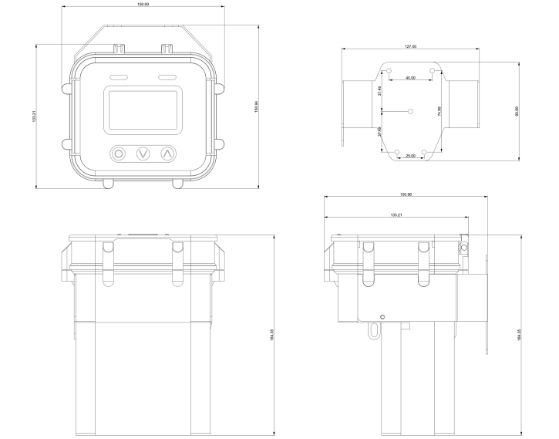
- Product dimensions

material quality
Shell material: ABS/PC

Installation and Use

Delivery inspection
Upon product delivery, users should first inspect the packaging quality. The packaging box must be intact without damage and bear clear labeling. If significant damage is observed, promptly contact the storage and transportation department to investigate the issue and determine responsibility, then notify our company. If no damage or other issues are detected, the product may be unpacked and its integrity verified through physical inspection.

Installation and Usage Notes
- When powering devices with external DC power, pay attention to the wiring sequence to avoid damage or malfunction caused by incorrect connections.
- The device antenna must be installed in a signal-optimized area; otherwise, it will increase communication power consumption and reduce battery life.
- When replacing the SIM card, battery, or output voltage during device use and requiring the top cover to be opened, avoid forceful lifting. Lift gently to prevent violent disconnection of screen wiring harnesses and other electrical components.
- Ensure the external quick-connect plug is properly connected when in use to prevent water ingress.
- When connecting external devices, pay attention to wiring to avoid damage to this device and connected external devices.
- Installation near vibration sources or impact sources should be avoided.
- The thread specifications of the joints for process installation must match the product specifications.
- During installation and use, wear, punctures, or scratches on the conductors must be strictly avoided. If such issues are present on-site, protective measures should be implemented for the conductors.

Interface wiring diagram
As shown in the figure below, the device's external interfaces are labeled A, B, C, and the antenna interface.
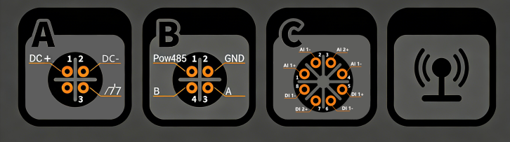
- Interface schematic diagram
The interface wiring is defined in the table below.
- Interface wiring definition
Interface | order number | definition
A | 1 | import DC+
A | 2 | import DC-
A | 3 | Input location
B | 1 | output POW
B | 2 | output GND
B | 3 | RS485A
B | 4 | RS485B
C | 1 | AI 1+
C | 2 | AI 1-
C | 3 | AI 2+
C | 4 | AI 2-
C | 5 | DI 1+
C | 6 | DI 1-
C | 7 | DI 2+
C | 8 | DI 2-

Installation Guide
As shown in the figure below, install the fixed bracket on the wall to be secured. Position the device according to the indicated direction on the bracket, and then secure it with screws on both sides of the device.

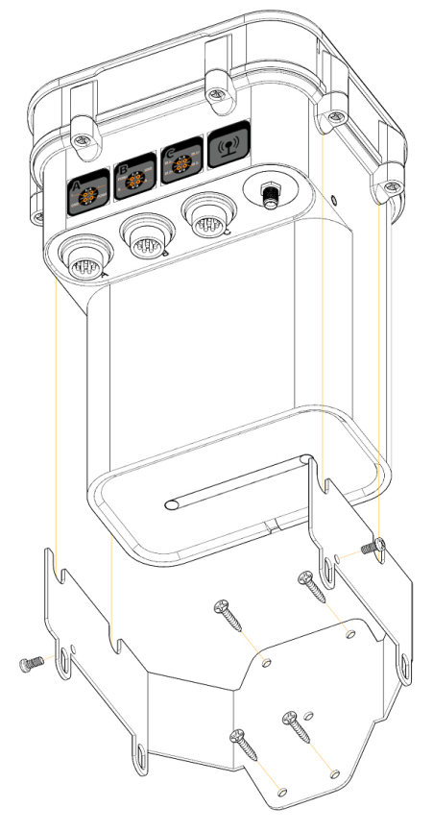
- Installation diagram
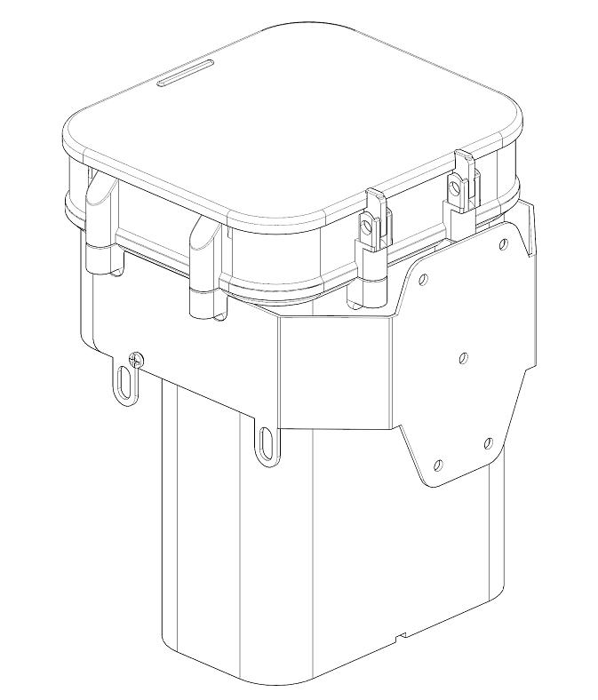
- Overall installation diagram

operate

Display and operation unit
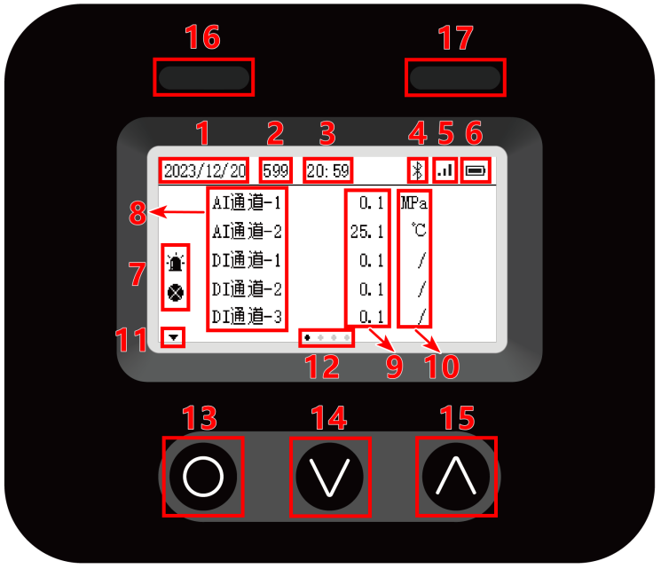
- Panel diagram

Interface Description
- Interface Description
order number | explain
1 | date
2 | Recognition countdown
3 | time
4 | Bluetooth connection identifier
5 | Upstream network status
6 | Power label and energy label
7 | Device channel status: Not displayed when normal, displayed during alarms, and displayed during faults
8 | Channel Identification
9 | Channel acquisition value
10 | Channel unit
11 | Page-turning marker
12 | Home page location marker

Key Instructions
Three operation buttons are located below the main screen.
- Key definition
order number | key | operate | explain
13 | O  （OK key ） | click | - Level switching on primary page  - affirm  - bit level switching  - Light up the backlight
13 | O  （OK key ） | Long press for 2 seconds | - Enter selection mode  - Exit selection mode  - Confirm saving the settings and exit
14 | ∨  Minus key | click | - Flip down page  - Select the next line  - Subtract 1 from the selected data bit value  - Next data option
15 | ∧  （ additional key ） | click | - Flip page up  - Select the previous row  - Add 1 to the selected data bit value  - Previous data option

Indicator light description
Two indicator lights above the main screen.
- Indicator light description
order number | explain
16 | Device communication indicator light  - The device displays bright green when submitting data.  - Turn off the device when no data is reported
17 | Device operation indicator light  - The light green color indicates normal device operation with flashing.  - When an equipment alarm occurs, the orange light flashes.  - When a device fails, it displays bright red and flashes.

field operations

Page Description
- Home page description
home page main page | Single-page display | explain
Home (Channel Page) | RS485 channel page | - Show the notification bar at the top of the screen  - The screen data area displays channel status, channel identifier, channel acquisition values, and channel units.
Home (Channel Page) | AI Channel Page | - Show the notification bar at the top of the screen  - The screen data area displays channel status, channel identifier, channel acquisition values, and channel units.
Home (Channel Page) | DI Channel Page | - Show the notification bar at the top of the screen  - The screen data area displays channel status, channel identifier, channel acquisition values, and channel units.
move  Status page | Web Information Page | - Display the page title at the top of the screen Status  - The data area displays upstream network parameters including RSSI/signal strength, SIM card, Operator, APN, and IP address.
move  Status page | Final report time page | - Display the page title at the top of the screen Status  - The data range shows the last report time (LastUpload).
move  Status page | Battery Level Page | - Display the page title at the top of the screen Status  - The data area displays the remaining battery power.
Configuration Page | Northbound Configuration Page | - Display page title at the top of the screen Config  - The data area displays northbound configuration parameters: Report Period, Cloud IP/Third-party Platform Address, CloudPort/Third-party Platform Port, Username/Third-party Platform Username, Password/Third-party Platform Password, Topic/Third-party Platform Reporting Topic, and Enable/Third-party Platform Reporting Enablement.
Configuration Page | Southbound Configuration Page | - Display page title at the top of the screen Config  - The data area displays the southbound configuration parameters: AI Period/AI sampling period, DI Period/DI sampling period, RS485 Period/RS485 sampling period, and RS485 baudrate/RS485 baud rate.
QR Code Page | two-dimension code | - Display the Bluetooth mini-program QR code on the left side of the screen  - Display the device information QR code on the right side of the screen

- Secondary page description
secondary pagesubordinate page | Single-page display | explain
channel  detail page | RS485 Channel Details Page | - Display the page title RS485 Channel at the top of the screen  - The data area displays the detailed parameters of the RS485 channel: Address, Identify, Status, and Value.
channel  detail page | AI Channel Details Page | - Display the page title AI Channel at the top of the screen  - The data area displays the AI channel details: Type, Identify, Status, and Value.
channel  detail page | DI Channel Details Page | - Display the page title DI Channel at the top of the screen  - The data area displays the DI channel details: Type, Identify, Status, and Value.
System Page | System Information Page | - Display the page title at the top of the screen System  - The data area displays device Version/Version number, SN, BLE MAC, IMEI, and Language.
System Page | Startup duration page | - Display the page title at the top of the screen System  - Data range display device Run Timer/Startup duration

operation declaration
- operation declaration
Operation item | operation declaration
Primary page navigation | - Click any key to turn on the screen, then click any key again to turn on the screen backlight  - Click the O key to scroll and switch between primary pages
page turning | - On the first-level page, click the ⋁ and ⋀ keys to flip pages down and up.
View channel details page | - Long press the O key for 2 seconds on the channel page to enter selection mode  - Click the ⋁ and ⋀ keys to switch channels up or down until you reach the channel you want to view.  - Click the O key to confirm your selection and go to the channel details page
Exit the channel details page | - On the channel details page, long press the O key for 2 seconds to exit the channel details page.
Exit selection mode | - In selection mode, press and hold the O key for 2 seconds to exit selection mode
View System page | - Click the O key to switch to the QR code page  - Long press the O key for 2 seconds to enter the System page
Exit System/System Page | - On the System page, click ⋀ to exit the System page.
Modify parameters | - Press and hold the O key for 2 seconds to enter the device configuration page (Config page parameters/System page Language parameters) and select mode.  - Click the ⋁ and ⋀ keys to switch options up or down until you reach the option you want to modify.  - Click the O key to confirm the selection and edit  - For numeric parameters, switch data bits by pressing the O key, or decrement or increment data bits by pressing the ⋁ or ⋀ keys.  - If it is an optional parameter, click the ⋁ or ⋀ key to switch options  - Long press the O key for 2 seconds to save and exit editing

Cloud migration for devices
This product can be connected to devices via the "Shidian Equipment Assistant Mini Program" or web interface, enabling remote monitoring, anomaly alerts, data reporting, and other functionalities.

Device cloud platform
(1) Mini Program
Search for the mini program "Shidian Equipment Assistant" on WeChat and add it.
(2) Web interface
Web address: https://www.west-iot.com/wessass

Add device
Step 1: Go to the Device Management interface of the Mini Program project
Click Projects--Select a project--Click--Click Device Management.
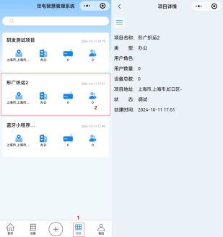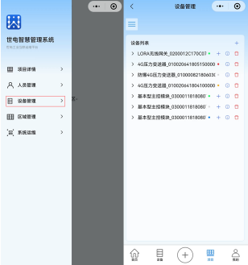
- Go to the project device management interface
Step 2: Add device
Click the + icon in the upper right corner of the Device Management page, select a product, and choose an addition method: manual addition, QR code scanning, or QR code scanning.
Scan to add:
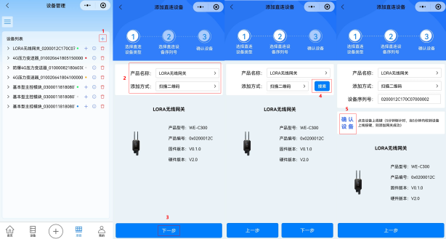
- Scan the device QR code to add
Add manually:
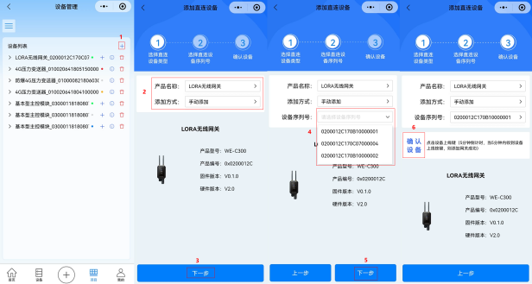
- Add manually
Bluetooth add:
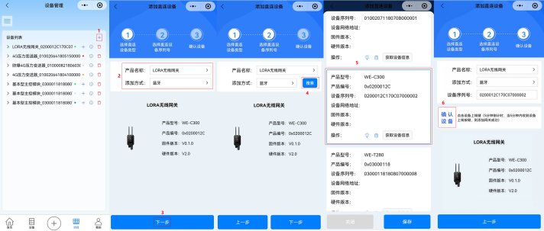
- Add Bluetooth

Guide to Device Cloud Platform and Mini Programs
After the device is added successfully, you can view the device in the project. Detailed operation guides for the cloud platform and mini program are available in the mini program document center.

Device local Bluetooth configuration
Step 1: Open the mini program and search for devices via Bluetooth
Click--Click to search for devices. After finding the device you want to connect to, click Stop Search.
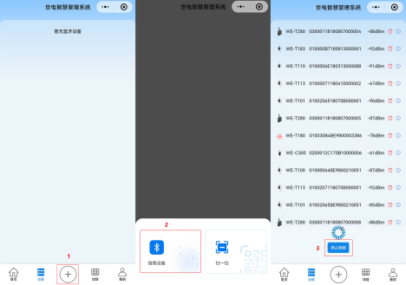
- Bluetooth search device
Step 2: Connect the device via Bluetooth
Click the device name to connect.
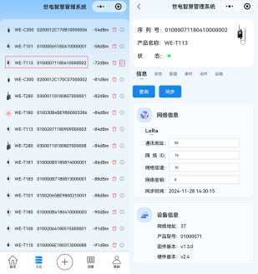
- Bluetooth-connected device
Step 3: Operate the device
After successfully connecting the device, you can view device status data in Status, modify device properties in Configuration, and restart, identify, or upgrade the device in Operations.

Fault Analysis and Troubleshooting
The table below lists potential issues and solutions for multifunctional detectors. If your problem is not listed or the solution does not address your issue, please contact our company.
- Common Fault Analysis and Troubleshooting
fault phenomenon | analysis of causes | Exclusion method
Instrument display absent | Low battery level | Replace the battery
Abnormal acquisition value | Sensor connection disconnected | If the channel status is disconnected, check whether the on-site host is properly connected to the probe.
Abnormal acquisition value | The configuration of the RS485 channel does not match the actual sensor register | Reconfigure RS485 channel parameters
Cannot receive data | The 4G network can determine the instrument status through indicator lights. If network registration fails, the following checks will be performed:  Is the SIM card properly installed and within the wireless network coverage area? | (1) Install the SIM card correctly, (2) Contact your network provider to set up the network, or check the signal strength of the local 4G network.
Card not read | Card not inserted properly / Card not used / Card bound | Replug  Check data plan renewal  Unlink Card
The platform has no data | The general procedure has a BUG | audit program

Quality Assurance and After-sales Service
Our company hereby guarantees to customers that during the warranty period, any product quality issues will be addressed through unconditional three guarantees service, including free repair, replacement, or return. All non-customized products are eligible for return or exchange within 7 days (excluding products damaged during use), while customized products shall adhere to the warranty terms specified in the contract.

disclaimer
During the warranty period, product failures caused by the following reasons are not covered by the three guarantees service:
(1) Product malfunction caused by improper use by customers.
(2) Product malfunction caused by customers' unauthorized disassembly, repair, or modification of the product.

Appendix Selection and Ordering
WE-T800 Product Selection Parameter Table

Parameter category | Selection Code and Specification Description
P power supply mode | P0: Powered by a 114,000mAh battery
P power supply mode | P1: Powered by 9~30VDC
P power supply mode | P2: Powered by a 228,000mAh battery
G Collection Type | G0: RS485 data acquisition
G Collection Type | G1: RS485 data acquisition, 2-channel AI, 2-channel DI
Note: Customization requires customer service consultation
instance ：
WE-T800-P0-G0
Multifunctional detector, powered by 114000mAh battery, RS485 data acquisition


Hainan Shidian Technology Co., Ltd. store.west-hn.com Hainan Shidian Technology Co., Ltd. store.west-hn.com
Scan the QR code for more information
Service hotline: 0086-21-33675566

