WE-T214 Sensor installation and usage specifications
The WE-T214 Sensor, a three-in-one soil moisture-conductivity-temperature sensor, delivers more accurate measurements during prolonged monitoring after irrigation or rainfall. For quick testing, water the soil first and wait for complete drainage before measurement. When measuring on hard surfaces, drill a hole smaller than the probe diameter, insert the sensor, compact the soil, then measure. Avoid violent vibrations or impacts, and never use hard objects to strike the sensor. Since the black-clad sensor can heat up rapidly under intense sunlight (over 50°C), ensure proper shading and protection in field or outdoor environments to prevent temperature spikes affecting its accuracy.
The specific installation and use specifications of MST Sensor are as follows.

I. Quick test
1. Select the appropriate measurement location, avoid stones and similar hard objects, and ensure that the steel needle does not touch hard objects;
2. Dig the surface soil according to the required measurement depth, keep the original tension of the soil below, hold the sensor vertically into the soil, and do not shake it left and right when inserting;
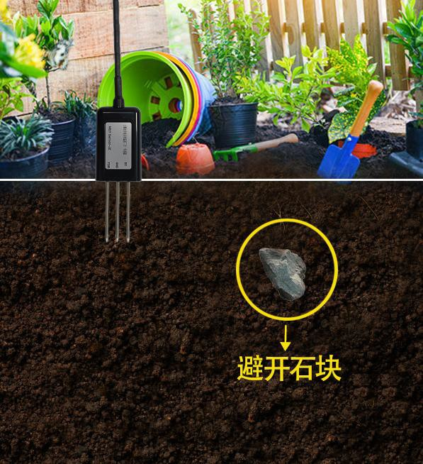
3. It is recommended to measure the small area of a measurement point several times and calculate the average value.
Avoid the rocks

II. Burying method
1. Dig a vertical pit with a diameter of about 20cm.

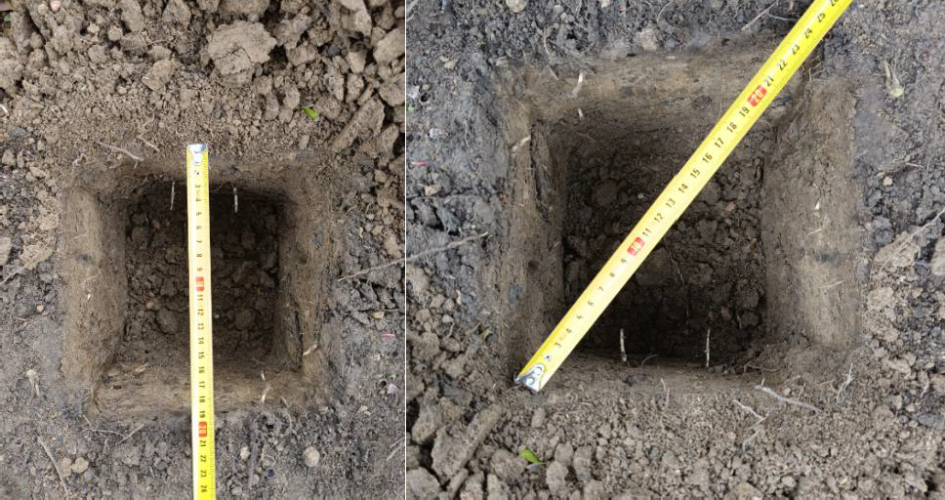

2. Insert the steel needle of the sensor horizontally into the pit wall according to the depth required for measurement (about 15cm).
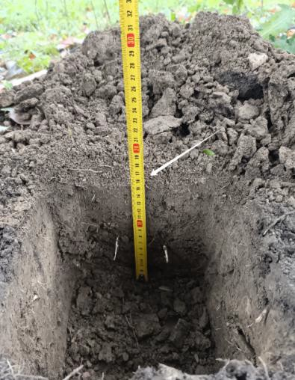
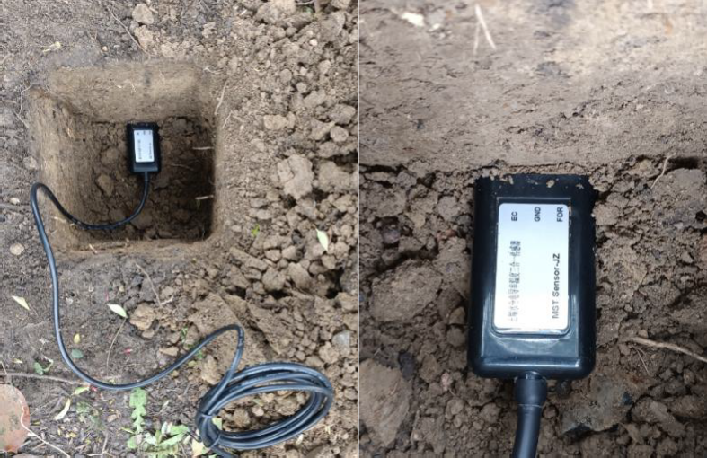
3. Backfill the excavated soil and compact the soil to maintain the same horizontal height of the soil before and after excavation.
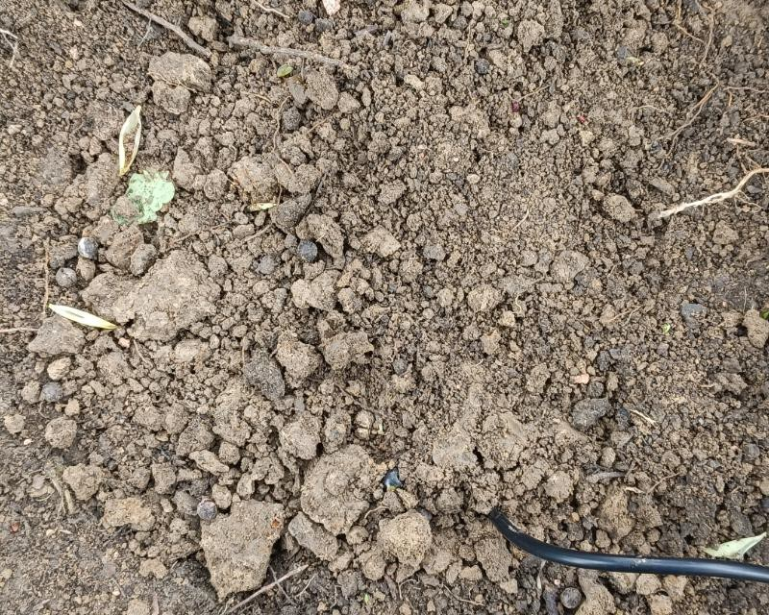
4. After the sensor is stable for a period of time, it can be measured and recorded continuously for a long time.

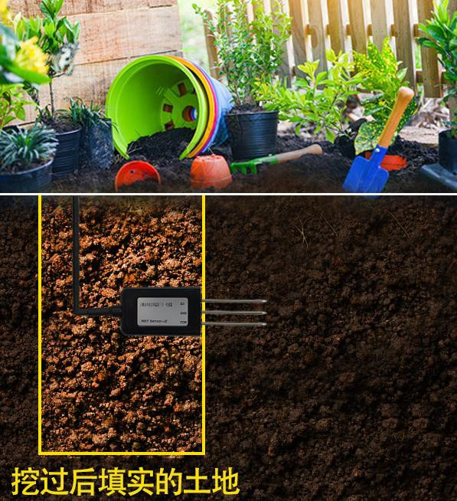
After digging, fill it with soil.

III. PRECAUTIONS

1. Before measurement, soil with uniform density should be selected as the object of measurement. During measurement, the steel needle must be fully inserted into the soil to avoid touching the bottom;
2. Avoid direct exposure of the sensor to strong sunlight to cause high temperature, and pay attention to lightning strike in field use;
3. Do not bend the steel needle violently, do not pull the sensor lead wire hard, do not throw or hit the sensor;
4. When there are hard blocks or foreign objects in the soil under test, the position of the soil under test should be selected again;
5. Because of the radio frequency electromagnetic radiation in the air, it is not suitable to be in an electric state for a long time;
6. During long-term measurement, the relative position of the sensor and cable should remain unchanged, and the bundle line should be kept dry as far as possible;
7. During the installation and use of sensors, try to maintain the original tension of the soil (excluding non-natural factors).

